**OPTIMIZING WORKFORCE EFFICIENCY AND TRAINING THROUGH MACRO ENABLED DASHBOARD**

Summer Internship Project Report submitted in partial fulfillment of the requirements for the degree of

Master of Business Administration

### By

**DANIEL JOE GASPER  
REGISTER NUMBER 2428707**

**Under the Guidance of**

**PROF. NAGENDRA BV**



**School of Business and Management CHRIST (Deemed to be) University, Bangalore**

**JULY 2025**

**OPTIMIZING WORKFORCE EFFICIENCY AND TRAINING THROUGH MACRO ENABLED DASHBOARD**

Summer Internship Project Report submitted in partial fulfillment of the requirements for the degree of

Master of Business Administration

### By

**DANIEL JOE GASPER REGISTER NUMBER 2428707**

**Under the Guidance of**

**PROF. NAGENDRA BV**



**School of Business and Management CHRIST (Deemed to be) University, Bangalore**

**JULY 2025**



**DECLARATION**

I hereby declare that the Summer Internship Project report titled “OPTIMIZING WORKFORCE EFFICIENCY AND TRAINING THROUGH MACRO ENABLED DASHBOARD”at Pantaloons has been undertaken by me in partial fulfilment of the requirements for the award of the degree of Master of Business Administration. I have completed this study under the guidance of Prof Nagendra BV.

Place: Bangalore

Daniel Joe gasper

2428707

Date:



**CERTIFICATE**

This is to certify that the Summer Internship Project report submitted by Daniel Joe Gasper on the title “Optimizing Workforce Efficiency and Training through Macro Enabled Dashboards ” is a record of Summer Internship Project work done by him during the academic year 2024-25 under my guidance and supervision in partial fulfilment of the requirements for the award of the degree of Master of Business Administration.

Place:

Date:

Prof Nagendra BV

School of Business and Management

Christ (Deemed to be University)

Bangalore



**Acknowledgment**

I am indebted to many people who helped me accomplish this Internship successfully. First, I thank the Vice Chancellor, CHRIST (Deemed to be University), Dr Fr Joseph C C, for giving me the opportunity to do my project. The leadership team at SBM (School of Business and Management), Bangalore Central Campus led by Dr. Jain Mathew, Dean, Dr. Sathiyaseelan B, Associate Dean, Dr. Mareena Mathew, Head of the Department and Dr. Lakshmi Shankar Iyer, Head of Business Analytics specialization ensures that all students gain relevant knowledge and skills through all courses especially courses like summer internship projects (SIP). The leadership team must be thanked for their efforts in guaranteeing quality internships for us.

I wish to express my sincere thanks to Pantaloons ltd and to my corporate mentor, Arif M, HR Manager, for giving me an opportunity to work under his guidance and successfully complete my internship.

My academic mentor Prof.Nagendra BV, deserves a special mention of gratitude for guiding me throughout my internship. The inputs I received from my mentor during the weekly meetings helped me to get a deeper understanding of my project.

 I thank my parents for their blessings and constant support, without which this internship project would not have seen the light of

Daniel Joe Gasper

2428707

**TABLE OF CONTENT**

|  |  |  |
| --- | --- | --- |
| **Chapter No** | **Title** | **Page No** |
| 1 | Introduction | 8 |
| 2 | Company and Industry Profile | 12 |
| 3 | Objectives | 15 |
| 4 | Project Design, Technique and Methodology | 18 |
| 5 | Data Analysis | 30 |
| 6 | Findings | 45 |
| 7 | Conclusion, Recommendation and Appendix | 47 |

**INTERNSHIP CERTIFICATE**



**EXECUTIVE SUMMARY**

This work was completed during my internship at Pantaloons, a leading Indian fashion retail chain owned by Aditya Birla Fashion and Retail Limited. Pantaloons recognized the necessity to update its employee training and engagement monitoring systems. Historically, HR teams depended significantly on manually extracting data from their ERP systems, which was followed by extensive analysis in Excel spreadsheets. This manual method was both time-intensive and susceptible to mistakes, which also postponed the provision of actionable insights to managers and leadership. The HR department faced challenges in monitoring employee skill development, which was required every 15 days via ERP-driven training modules to ensure employees remained informed about new product information. The current method required manually gathering training completion information, creating Excel reports, and conducting drop analysis individually, which was ineffective and delayed decision-making.   
  
To tackle these issues, Pantaloons created a VBA-driven, macro-enabled dashboard that automated the retrieval, processing, and visualization of employee engagement and training information. This smart dashboard delivered immediate insights, greatly lessening manual tasks and allowing HR to track training progress and certification achievements across areas with improved accuracy and speed. The solution equipped Regional Human Resources (RHRs) and Regional Store Managers (RSMs) with current, trustworthy data to make well-informed choices regarding employee distribution, training adherence, and resource allocation.   
  
The initiative commenced with thorough stakeholder interviews that included HR leaders, RHRs, and RSMs to grasp their reporting requirements and challenges. Key performance indicators like employee numbers, certification percentages, and regional analyses were established. Data was gathered from various sources such as SAP ERP systems and Excel files, then processed and normalized to maintain uniformity. The information was organized into a cohesive dataset containing important fields like Employee ID, area, certification status, and training dates.

An Excel-based star schema data mart model was designed to facilitate efficient querying and reporting. This model included a central fact table that recorded employee training completion information associated with dimension tables for employees, training modules, and products. VBA macros facilitated the extraction, cleaning, and conversion of unprocessed ERP data into this organized format. The dashboard featured dynamic visuals—bar graphs for staff distribution, donut charts for certification rates, line graphs for trend monitoring, and geographic maps for regional density display—providing an engaging and user-friendly interface with dropdowns and slicers for filtering by region, manager, or state.

Prior to adopting this solution, HR teams extracted data manually from SAP ERP every 15 days, moved it to Excel, and carried out repetitive cleansing and aggregation tasks that were susceptible to errors and inconsistencies. Reporting was inflexible and lagged, lacking the capability to explore details or track training progress in real-time. This led to significant delays, potential data inaccuracies, and restricted scalability as the workforce expanded. Administrative overhead consumed HR resources, restricting strategic emphasis.   
  
After implementation, the ETL process driven by VBA automated the extraction and transformation of data, removing manual downloads and decreasing error spread. The integration of data into a star schema allowed for quick, multidimensional analysis of training metrics. Real-time dashboards offered immediate updates, enabling HR to identify skill gaps and compliance risks in advance. Automated notifications and detailed analysis features improved operational responsiveness and decision-making flexibility. The hybrid framework utilizing VBA and current Microsoft Office applications demonstrated cost efficiency, eliminating the necessity for extensive data warehousing expenditures while providing scalable analytical solutions.   
  
The macro-enabled workforce engagement and training dashboard revolutionized Pantaloons’ HR reporting by changing it from a sluggish, mistake-ridden manual procedure into an effective, automated, and insightful system. This upgrade increased data precision, decreased reporting delays from bi-weekly to almost real-time, and boosted query performance, allowing for more precise, data-informed decisions. The solution reinforced Pantaloons’ dedication to ongoing employee growth and operational excellence, nurturing a more agile and knowledgeable learning environment throughout its retail network.

**CHAPTER 1**

# INTRODUCTION

Pantaloons, a prominent fashion retail chain in India owned by Aditya Birla Fashion and Retail Limited, functions in a fast-changing retail landscape characterized by heightened competition, evolving consumer habits, and technological improvements. The retail industry currently encounters major difficulties such as increasing operational expenses, elevated staff turnover, and the necessity for flexible workforce management. In this scenario, conventional HR models that depend largely on manual procedures and fixed reporting are becoming more insufficient.   
  
Retail HR teams are overwhelmed by administrative responsibilities that hinder their focus on strategic workforce growth, while managers find it difficult to obtain timely and precise information regarding employee training and engagement. For Pantaloons, which focuses on regular employee upskilling every 15 days via ERP-based training modules, these challenges were especially prominent. The manual retrieval of training data from ERP systems, along with tedious data cleansing and reporting in Excel, resulted in delays, mistakes, and restricted insight into training compliance and workforce preparedness across different regions.   
  
This evolving landscape made it crucial for Pantaloons to embrace a more contemporary, automated method for HR analytics and training management. The requirement was not just to minimize administrative burdens but also to facilitate real-time, data-informed decision-making that bolsters a flexible and competitive retail operation. The solution needed to deliver precise, reliable, and prompt insights into employee training advancement, certification levels, and regional performance analyses, enabling HR leaders and store managers to implement proactive measures.   
  
Moreover, as the retail industry increasingly prioritizes employee engagement, retention, and skill enhancement, the capability to effectively track and analyse workforce data has become a crucial strategy for maintaining business expansion and customer contentment.   
  
The primary aims of this project were to

* Enhance and automate the HR reporting workflow by substituting manual data management with a macro-enabled, VBA-driven dashboard; increase data precision and uniformity to foster confidence in workforce analytics;
* Through reaching these objectives, Pantaloons intended to shift its HR function from a reactive, administrative position to a proactive, strategically that fosters continuous learning and operational excellence in a competitive retail environment.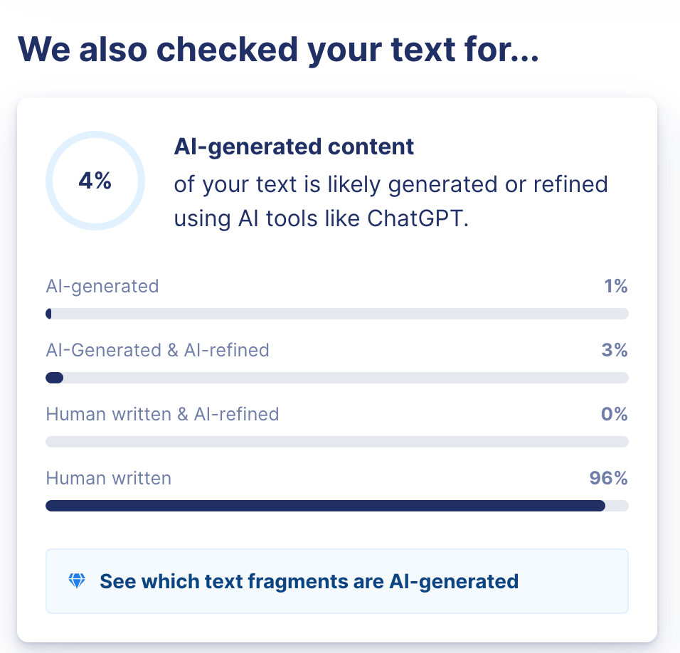

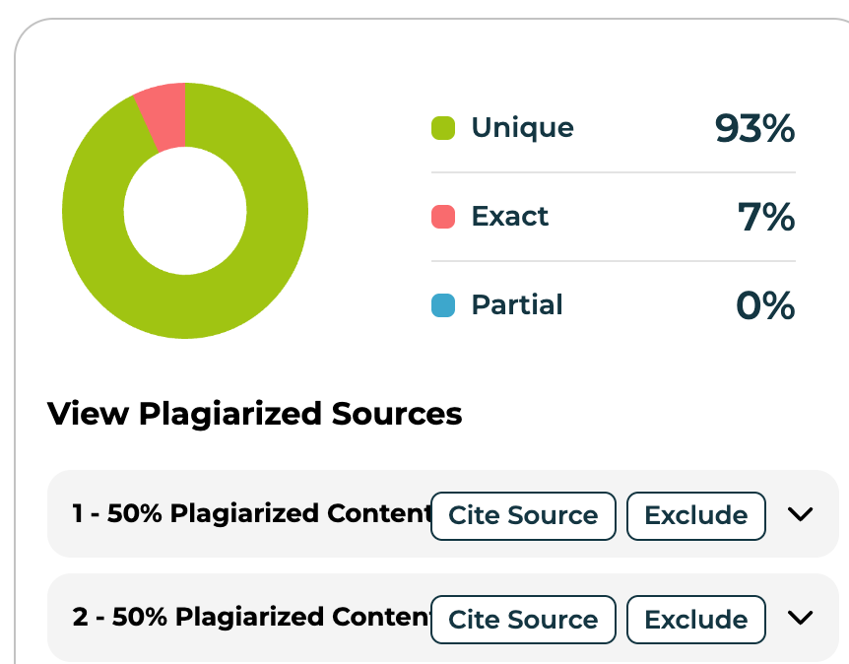

**CHAPTER 2**

# INDUSTRY AND COMPANY PROFILE

## INDUSTRY PROFILE

• Pantaloons functions in India’s vibrant and swiftly growing organized retail sector, which is valued at $1.2 trillion in 2025 and expected to double in the coming ten years. The industry is marked by a transition to structured and omni-channel retailing, propelled by urban growth, increasing disposable incomes, and greater digital engagement. Fashion and clothing lead the retail leasing sector, as both foreign and local brands are expanding rapidly.   
  
• Pantaloons faces competition from Max Fashion, Westside, Lifestyle Stores, AJIO, Reliance Trends, and Fabindia, all employing distinct strategies like value pricing, private label emphasis, digital-first approaches, and curated assortments to gain market presence. The competitive environment is further heightened by the arrival of international brands and the surge of online shopping platforms, which have changed consumer demands for selection, ease, and cost.   
  
• Government regulations significantly influence the expansion of the retail industry. Recent efforts feature the National Retail Trade Policy, designed to simplify regulations, lessen compliance burdens, and encourage formalization within the sector. The government is additionally assisting the industry via job-related incentive programs, accessible funding for small businesses, and investments in digital infrastructure to promote growth in both online and physical retail. The Open Network for Digital Commerce (ONDC) is a groundbreaking initiative aimed at making e-commerce accessible to local retailers and creating an equitable environment.   
  
• Moreover, the government is encouraging sustainability by providing incentives for environmentally friendly practices and bolstering domestic manufacturing with enhanced Production-Linked Incentive (PLI) programs.   
  
The Indian retail sector encounters obstacles like inflationary pressures, supply chain limitations, and intense rivalry for premium retail locations, yet these issues are being tackled through technological integration, especially AI and automation, along with growth into tier II and III cities and favorable policy frameworks.

Thanks to strong consumer demand, continuous digital transformation, and a supportive regulatory framework, the sector is set for ongoing expansion, placing companies such as Pantaloons at the leading edge of India's retail progression.

## COMPANY PROFILE

Pantaloons is a prominent fashion retail brand in India and part of Aditya Birla Fashion and Retail Limited (ABFRL), based in Mumbai. Founded in 1997 as a segment of the Future Group, it was purchased by the Aditya Birla Group in 2013.

• Retail Presence: Pantaloons has more than 400 stores in over 190 cities and towns throughout India, showcasing a robust nationwide footprint. The brand serves a varied clientele, emphasizing urban and semi-urban markets.

• Product Range: The firm provides an extensive selection of clothing and non-clothing items, featuring casual attire, business attire, traditional attire, party attire, and sportswear for males, females, and kids. Non-clothing categories consist of shoes, bags, makeup, fragrances, fashion accessories, and timepieces. Womenswear accounts for roughly fifty percent of overall clothing sales.

• Notable brands consist of Style Up for fashionable and budget-friendly youth apparel, Groovin’ for celebration clothing, Rangmanch and Akkriti for ethnic and fusion attire, Ajile for activewear, and Indus Route for traditional menswear. The kids' section includes brands such as Coolsters, Pantaloons Junior, and Chirpie Pie.

Main Difficulties Involve:

• Manual Data Management: The current procedure required manual retrieval and aggregation of training data from ERP systems, resulting in mistakes, holdups, and uneven reporting.

• Absence of Immediate Insights: Restricted interactivity and lack of a central data repository hindered prompt visibility into employee training progress and regional assessments.

To address the challenges and get ready for expansion, Pantaloons executed

• utilizing VBA macros for automating the processes of data extraction, cleaning, and transformation,

• greatly minimizing human mistakes and enhancing data precision.

Furthermore, a dynamic, macro-enabled dashboard featuring interactive filtering and drill-down options, facilitating real-time insights and scalable reporting across various regions, which fosters quicker decision-making and future expansion.

**CHAPTER 3**

# OBJECTIVES

## BUSINESS OBJECTIVES

## • Enhance HR Reporting Procedures: Automate the manual gathering, analysis, and merging of employee training information to lessen administrative burden and boost operational effectiveness.

## • Improve Decision-Making: Equip Regional Human Resources (RHRs) and Regional Store Managers (RSMs) with immediate, precise information regarding employee allocation, certification levels, and training completion statistics to facilitate data-informed workforce management.

## • Enhance Compliance Oversight: Guarantee prompt monitoring of certification achievements and compliance with required training timelines throughout all areas to uphold regulatory and organizational standards.

## • Activate Regional Performance Benchmarking: Allow swift and simple comparisons of workforce metrics across various regions, states, and managers to pinpoint skill deficiencies and distribute resources efficiently.

## • Foster a Continuous Learning Environment: Enhance employee involvement and skill development by offering clear, accessible training progress updates that promote responsibility and inspiration.

## ANALYTICAL OBJECTIVES

• Data Integration and Consolidation: Create a cohesive Employee Analytics Data Mart by integrating various data sources (ERP, HRIS, SAP, Excel) into a reliable, verified dataset that facilitates thorough analysis.

• Data Quality and Standardization: Apply deterministic cleaning and validation processes to remove duplicates, standardize identifiers for employees and modules, and guarantee accuracy and consistency in reports.

• Multidimensional Data Architecture: Create a star schema utilizing fact and dimension tables to facilitate quick slicing, dicing, and drill-down evaluations by department, area, role, product category, and training status.

• Real-Time and Historical Analytics: Facilitate near real-time data ingestion and provide historical trend analysis to monitor workforce preparedness, compliance risks, and training efficacy over time.

• Interactive Visualization and User Experience: Develop dynamic dashboards utilizing VBA-driven automation, engaging slicers, dropdown menus, and drill-down features to equip HR and management with actionable insights and easy navigation.

• Implement automated extraction of SAP data with checks for employee IDs, module associations, and time of completion.

• Create a star schema featuring conformed dimensions for Employee, Module, and Product to facilitate cohesive compliance and skill evaluation.

• Implement event-driven architecture to recognize training completions within 24 hours, facilitating prompt identification of at-risk groups and compliance concerns.

**CHAPTER 4**

# PROJECT DESIGN ,METHODOLOGY

# AND TECHNIQUE

**Project Design**

**Problem Statement:**

**Pantaloons encounters major difficulties due to the ineffective and manual monitoring of required 15-day employee training, depending heavily on unwieldy SAP ERP exports and Excel reporting. This outdated method not only causes delays in reporting and inaccuracies in data but also places an undue administrative strain on the HR team, hindering prompt insight into workforce compliance and skill preparedness. The lack of automated data integration and live analytics features significantly hinders efficient oversight and strategic choices, ultimately obstructing the organization’s capacity to uphold a flexible and adaptive talent development system.**

**Project Methodology**

**1. Requirement Gathering and Analysis**

* **Stakeholder Interviews:** Engage with Regional Human Resources (RHRs), Regional Store Managers (RSMs), and HR leadership to understand reporting needs, pain points with manual processes, and key performance indicators (KPIs).
* **Define Objectives:** Clarify business and analytical objectives such as headcount tracking, certification monitoring, regional comparisons, and timely decision support.
* **Identify Data Sources:** Determine where employee data, certification records, and regional information reside (HRIS systems, Excel files, Systems Application and Product Enterprise Resource Planning).

**2. Data Collection and Preparation**

* **Data Extraction:** Collect raw data from multiple sources, including employee master lists, training completion logs from the ERP.
* **Data Cleaning:** Standardize formats, remove duplicates, handle missing or inconsistent data to ensure accuracy.
* **Data Structuring:** Organize data into structured tables suitable for analysis, Employee ID, Name, Region, State, RHR, RSM, Certification Status, Dates.

**3. Data Integration**

* **Consolidation:** Merge data from different sources into a unified dataset, ensuring consistent keys for linking.
* **Validation:** Cross-check consolidated data with source systems to ensure correctness.

**4. Dashboard Design and Layout Planning**

* **KPI Selection:** Choose relevant KPIs such as employee count by region, certification completion percentage, and manager-wise performance.
* **Visualization Types:** Decide on charts and visuals that best represent the data:
  + Bar charts for employee distribution by RHR and state
  + Donut charts for certification percentages
  + Line graphs for trends or comparisons
  + Geographic maps for regional density visualization
* **User Interface (UI):** Design an intuitive layout with slicers dropdowns for RHR, RSM, state) and clearly labelled visuals for easy navigation.

**5. VBA Macro Development**

* **Automation Scripts:** Wrote VBA macros to automate:
  + Data import and refresh from source files
  + Data aggregation and calculation of KPIs
  + Dynamic updating of charts and tables based on user selections
* **Interactive Controls:** Implement dropdowns, buttons, and slicers linked with VBA code to enable filtering and drill-down capabilities.
* **Error Handling:** Include error checks to handle missing data or invalid inputs.

**6. Dashboard Construction in Excel**

* **Data Tables:** Set up  dedicated sheets for raw and processed data.
* **Charts and Visuals:** Insert and link charts to dynamic ranges populated by VBA macros.
* **Map Integration:** Use Excel’s map charts or custom shapes to represent regional data visually.
* **Formatting:** Apply consistent colour schemes, fonts, and conditional formatting to enhance readability and highlight key metrics.

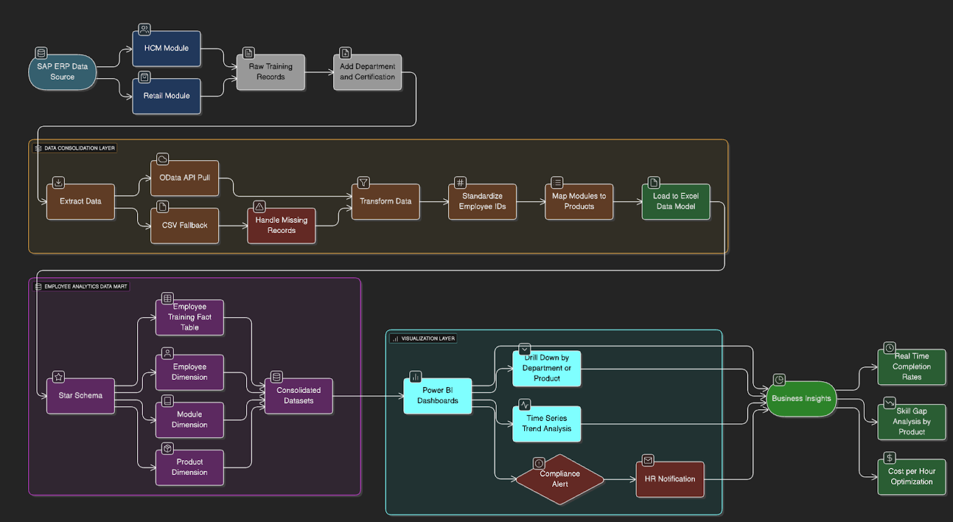

1. Data Integration & Automation:  
• The **process** **starts** with **combining** **key** **HR** **data** **sources**, **specifically** the Human Capital Management and Payroll **modules** from SAP ERP, to **gather** **records** of **training** and **employee** **details**.  
  
• **Rather** than **manually** **exporting** **data** from SAP, the **process** **uses** **automation** for **extracting** and **consolidating** **data**, which **lowers** the **need** for **manual** **work** and **minimizes** **mistakes**.  
  
  
2.  
Automated **ETL** Pipeline:  
• Data is **collected**, **cleaned**, **anonymized** for **privacy**, and **transformed** into **standard** **formats** **using** **APIs** and **advanced** **ETL** (Extract, Transform, Load) **tools**.  
  
• This **eliminates** the **need** for **manual** **data** **handling** in Excel, **ensuring** that **data** is **up**-to-**date**, **precise**, and **consistent**.  
  
  
3.  
Centralized & Structured Data Storage:  
• The **cleaned** **data** is **stored** in a **central** **location** **using** **well**-**organized** **models**, **such** as the Employee Training Fact and Product Dimension.  
  
• This **setup** **maintains** **data** **consistency** and **acts** as a **single** **reliable** **source** for **tracking** **employee** **development** and **training** **progress**.  
  
  
4.  
Business Intelligence & Analytics Deployment:  
• **Unified** **data** is **used** in Excel **dashboards** that **offer** **visual** **summaries**, **detailed** **analysis** by **departments** or **products**, and **tracking** of **training** **completion** **patterns** over **time**.  
  
• The **system** **includes** **automated** **alerts** and **notifications** for **HR**, **supporting** **timely** **action** on **training** **mandates** and **compliance** **needs**.  
  
  
5.  
**Actionable** **Insights** for **Effective** **Decision**-**Making**:  
• **HR** and **management** **receive** **clear**, **timely** **insights** on **training** **completion**, **exceptions**, and **trends** in **compliance**.  
  
• This **helps** Pantaloons to **continuously** **monitor** the **skill** **level** of their **workforce** and **respond** **quickly** to any **identified** **skill** **gaps**.  
  
  
6.  
**Outcome**: Agile & Accurate Compliance Management:  
• This **approach** **reduces** **delays** and **errors** in **reporting**.  
  
• It **lowers** the **workload** for **HR**, **improves** **transparency** in **compliance**, and **allows** Pantaloons to **manage** **workforce** **development** in a **more** **flexible** and **data**-**informed** **way**.

**TECHNIQUE USED**

Kimball Technical Data Warehouse and Business Intelligence (DW/BI) Architecture.

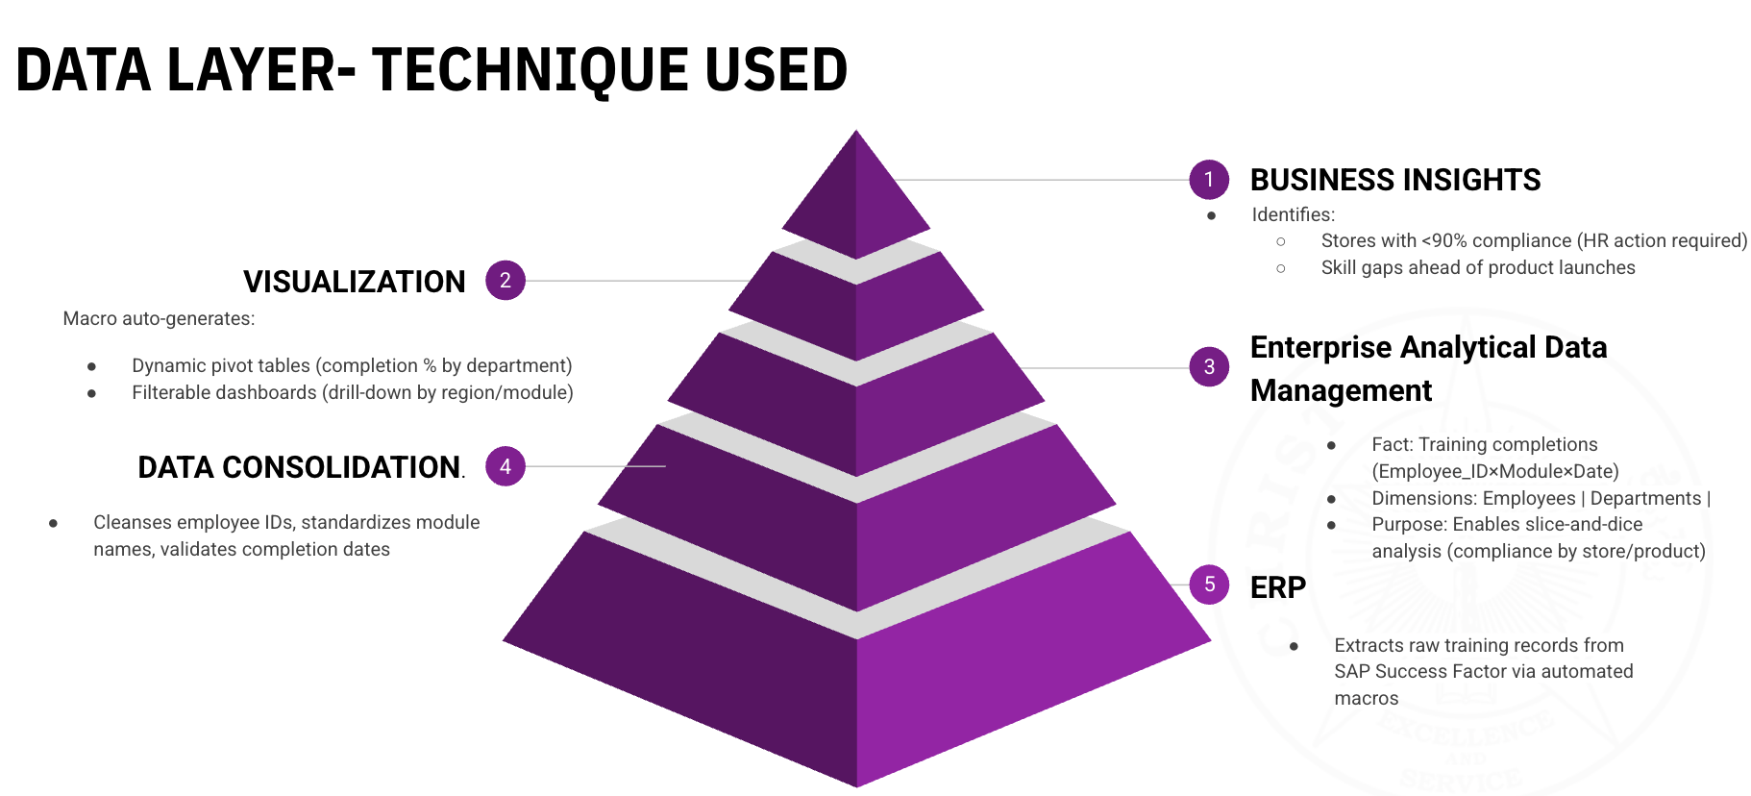

1. Business Insights Layer  
• Employs analytical engines to algorithmically identify entities (such as retail locations) with compliance rates falling below threshold levels (<90%), utilizing threshold-based notifications and exception reporting systems.  
• Incorporates predictive analytics to identify potential skill deficits through correlation analysis prior to key operational events like product launches.  
  
2. Visualization Layer  
• Implements dynamic, macro-driven OLAP (Online Analytical Processing) pivot tables for comprehensive analysis of training compliance KPIs (such as completion rates by department).  
• Facilitates hierarchical drill-down and filterable dashboards utilizing real-time data visualizations (through Power BI/Tableau integration), allowing for analysis of cross-sectional and longitudinal trends at both regional and module levels.  
  
3. Enterprise Analytical Data Management  
• Develops a solid enterprise data warehouse using star or snowflake schema, modeling training completions as fact tables (Employee_ID × Module × Date) and organizing departments/employees/products as dimension tables.  
• Supports advanced slicing and dicing along with ad hoc querying through enterprise BI tools, enabling detailed compliance analytics across various organizational dimensions (such as store, product, and employee segments).  
  
4. Data Consolidation Layer  
• Coordinates automated data cleansing processes to maintain referential integrity: standardizes employee identifiers, applies data normalization on module names, and enforces strict validation on completion timestamps.  
• Utilizes ETL frameworks to automate consolidation, ensuring data lineage and traceability for audit and compliance purposes.  
  
5. ERP Data Ingestion  
• Establishes automated data extraction workflows from SAP SuccessFactors through custom macros and API integration, guaranteeing near real-time acquisition of raw transactional training data.  
• Implements batch or streaming ingestion methods as needed to reduce latency, ensuring a smooth transition of source data into the analytical environment.

**CHAPTER 5**

# DATA ANALYSIS AND INTERPRETATION

**DATA DICTIONARY**

|  |  |  |
| --- | --- | --- |
| **Variable Name** | **Data Type** | **Description** |
| Country | Text | Country and Location of South Zone |
| State | Text | South Zone Located Regions (Karnataka, Kerela, Tamil Nadu, Telangana, Andhra Pradesh) |
| Region | Text | Various sub-locations within the state where stores are located. |
| Store Code | Numeric | Unique Code for Identifying each Store. |
| Employee Code | Numeric | Unique Employee code for common Categorization in Completion Status. |
| Employee Name | Text | Name of Each Employee and Designation |
| Regional Store Manager | Text | 4 Regional Store Managers |
| Regional Human Resource Manager | Text | Number of Regional Human Resource Managers |
| Drop Completion Percentage | Numeric (%) | Percentage of drop completion (100, 0, blank). (Completed,Not Completed, Employee ID not available) |
| Drop Completion | Text | Status of drop completion (Yes/No/Null). (Competed, Not Completed, ID not available-Employee- left) |
| Drop Certification | Text | Certification status (Yes/No/Null). |
| Drop Certification Percentage | Numeric (%) | Percentage of drop certification (100, 0, blank). |

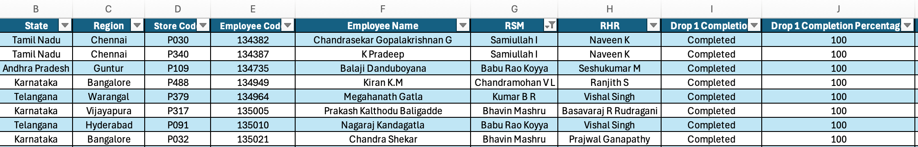

* Data as extracted from the ERP Software with excel on basis of Module Completion.
* Drop Completion Percentages ranges from the start of the financial year 1/4/2025 – 31/5/2025.
* Employee Code is unique and in case any Module is not registered with the ID null would be displayed in the Pivot Table.
* RHR is above the RSM in hierarchy and oversees the entire functioning of that particular store and region.
* Completion has been assigned 100, Not completed 0 and ID#Not found as Null with an appropriate IF Condition.

#### AS IS PROCESS IN PANTALOONS

**1) This opening section outlines the stages involved in gathering and preparing data:  
• Begin Manual Process: The workflow is triggered through human initiation to kick off the operation.  
• Log into SAP GUI: Accessing SAP GUI relies on engaging with the SAP Graphical User Interface; user input is necessary for the SAP Enterprise Resource Planning (ERP) system, likely requiring navigation through different transaction codes (t-codes) to retrieve specific information.  
• "Win PAZB and LEEO, TAKEN Transactions": Certain SAP transactions (like PAZB, LEEO, TAKEN) are carried out to extract or handle data. "Win" signifies successful execution or retrieval from these transactions.  
• Export Training Data to CSV: The data pulled from SAP is subsequently exported into a Comma Separated Values (CSV) file format. This step is a standard method for data transferability and further manipulation outside the SAP environment.  
• 15 Min Timeout or Missing Employee IDs: A 15-minute timeout signifies an operational limitation or an error during data extraction or transfer, possibly reflecting a system restriction or network complication. "Missing Employee IDs" indicates a data integrity concern where essential identifiers are lacking, leading to incomplete data.  
• Manual Correction of Employee IDs: Intervention is necessary to rectify or add missing Employee IDs, stemming from the data integrity problem. This represents a bottleneck and introduces a possibility for human error.  
  
2) This section explicitly identifies major challenges within the existing process, highlighting significant issues prior to your project:  
• 1%-8% Percent Error Rate in Final Reports: An error rate of 1%-8% is present in final reports, rendering the data and calculations unreliable. This directly affects decision-making and regulatory compliance.  
• 4 Week Lag in Compliance Visibility: There is a four-week lag in acquiring compliance information. This hinders prompt detection and correction of compliance violations, risking the organization.  
• No Real-Time Alerts for Expirations: The absence of real-time alerts for expirations (such as certifications, licenses, training) leads to a reactive stance toward compliance and operational management, increasing the risk of non-compliance or disruptions in operations.  
  
3) This section outlines the data processing and preparation actions undertaken by an "Analyst," employing tools like Excel:  
• VLOOKUP (SM): VLOOKUP (SM) pertains to utilizing the VLOOKUP function, a widely used feature in spreadsheets. "SM" stands for "Store Master" or a similarly pertinent data source for lookups, utilized for data enrichment.  
• Merge CSV Files: Several CSV files are integrated into a unified dataset, bringing together fragmented information for analysis.  
• Remove Duplicates and Fix Formatting: Standard data cleansing procedures are undertaken to maintain data integrity and uniformity. Eliminating duplicates is crucial as they can distort analysis, while inconsistent formatting may obstruct further processing.  
• VLOOKUP SAP Codes to Module Names: A subsequent VLOOKUP operation is carried out to correlate obscure SAP codes with clearer module names. This improves readability and usability of data for reporting purposes.  
• Version Conflict (Multiple Editions): Version Conflict (Multiple Editions) represents a significant complication. Different versions of data or reports exist concurrently due to insufficient version control, resulting in confusion and the risk of relying on outdated or incorrect information.  
  
4) This section discusses the collaboration with Store Managers for the purposes of data validation and correction:  
• Manual Review for Discrepancy Verification: Store Managers are directly engaged in examining data to confirm discrepancies. This process is time-intensive and susceptible to errors.  
• 36 Hour Response Delay (18-12 Hrs): There is a considerable lag (36 hours, with an indicated range of 18-12 hours) in obtaining replies from Store Managers. This creates a substantial hurdle, affecting the overall turnaround time of the process.  
• No Audit Trail for Corrections: The lack of an audit trail implies that alterations made by Store Managers remain unmonitored, complicating the ability to identify who made specific changes, their timing, and rationale. This poses a significant issue for compliance and data governance.  
• VLOOKUP (SAP Rework): After the review, an additional VLOOKUP function is executed to align or amend data to fit an SAP-compatible format or incorporate SAP data itself. "Rework" refers to the ongoing cycles of correction.  
  
5) This section concentrates on the final data validation and reconciliation:  
• 10x Cross-Check 10 Man Days of Records Against SAP: A "10x Cross-Check" signifies a verification of records against SAP requiring 10 man-days of effort, highlighting an extremely labor-intensive validation approach. This process involves multiple layers of verification and considerable manual labor to ensure the records align with SAP, thus ensuring accuracy and completeness. It demands substantial resources.  
• Remove Duplicates and Fix Formatting for Rework: Even at this advanced stage, issues with data quality such as duplicates and formatting continue to arise, necessitating additional rework and the repetition of prior processes.  
• Loop for Rework: A "Loop for Rework" characterizes an iterative and inefficient method where mistakes or inconsistencies are sent back to earlier phases for correction, prolonging cycle time and increasing workload.  
  
6) This concluding section outlines the output and its related challenges:  
• Create Post Sales for Compliance: Reports concerning post-sales activities are generated to ensure compliance.  
• Email Static Excel Reports to Leadership: Reports are created in Excel format and manually sent via email. This represents a static reporting method that lacks interactivity or real-time updates.  
• Reports Outdated Upon Delivery: Upon delivery, the reports are already outdated, which is a fundamental problem. This is due to significant delays encountered throughout the entire process.  
• No Drill-Down Capabilities: The static Excel reports do not possess the ability to drill down into the underlying data for a more comprehensive analysis, thereby restricting insights and necessitating further manual effort for deeper investigation.  
• End of Process**

**POST AUTOMATION PROCESS**

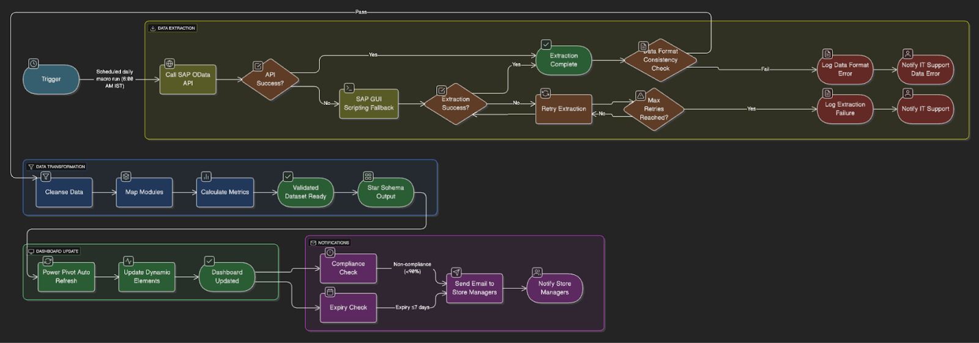

1. Daily Automated Extraction of Employee Learning Data from SAP

Every morning at 6:00 AM IST, an automated process is initiated to extract the latest employee learning and HR module information from the SAP HR system (such as SuccessFactors or SAP HCM). This process gathers data points including employee ID, training modules assigned, completion rates, timestamps, and overdue indicators. This routine trigger guarantees up-to-the-minute visibility of training compliance across all Pantaloons stores and regional offices—keeping HR and store managers updated without the necessity for manual oversight or action.

2. SAP OData API Invocation for Learning Module Records with GUI Backup

The system makes a request to the SAP OData API to obtain organized records related to HR modules. The API pulls specific employee data, which includes:

• Assigned modules (for instance, POS training, Code of Conduct, Fire Safety)

• Completion status (Complete, In Progress, Not Started)

• Assignment and completion dates

• Employee information (Name, Store ID, Role)

If the API encounters issues (like downtime, authorization problems, or endpoint changes), the automation reverts to SAP GUI scripting. This backup method emulates navigating the SAP GUI to generate training reports and export employee completion logs as Excel or CSV files. This dual-method strategy guarantees continuous data acquisition, even during technical failures.

3. Data Extraction Verification and Schema Consistency Assessment

Once the data extraction occurs (via either API or GUI), the system carries out a dual-validation process:

• Success Confirmation: Validates that the dataset is available, comprehensive, and contains current entries. For instance, it verifies that each of the 12,000+ Pantaloons employees has an associated HR module record.

• Format Verification: Confirms that the layout of the extracted file matches the defined schema—checking columns such as Employee_ID, Module_Name, Completion_Status, Due_Date, Store_ID, and Last_Updated_Timestamp.

Should discrepancies in format or data shortages be identified, the system attempts extraction again or alerts IT support. Errors may occur if a new module has been added to SAP but isn't represented in the integration schema.

4. Data Cleaning, Mapping, and Enrichment of HR Module Information

The unrefined data undergoes a cleansing process to eliminate:

• Duplicate module entries per employee

• Missing or improperly formatted completion statuses

• Incorrect dates (e.g., completion dates that precede module assignment)

After cleansing, the data is mapped to align with store and HR structures. For example:

• Employee_ID is linked to Region, Store_Manager, Designation

• Module_Name is associated with Module_Category (like Compliance, Technical, Soft Skills)

This alignment allows reports to be categorized not just by store but also according to training type or employee hierarchy.

5. Calculation of HR Completion Metrics and Final Dataset Readiness

From the refined dataset, various completion-focused key performance indicators (KPIs) are calculated:

• Completion Rate per Store = Completed Modules / Assigned Modules

• Non-Compliance Rate = Percentage of employees with less than 90% completion

• Overdue Modules = Modules that remain incomplete beyond their due dates

• Employee Compliance Score = Weighted score of modules completed punctually

The system checks for data accuracy (no employee should have more completed modules than assigned) and highlights any discrepancies. After validation, the final dataset is deemed "ready" for dashboard presentations and alerts.

6. Structuring Star Schema for Business Intelligence Dashboard and Notification Triggers

The finalized dataset is formatted into a Star Schema that includes:

• Fact Table: HR_Module_Completion_Fact, which records training activities for each employee

• Dimension Tables: Employee_Dim, Module_Dim, Store_Dim, Date_Dim

This setup enables the integration into dashboards (Power BI, Tableau) where regional HR leaders, compliance personnel, and store supervisors can:

• Observe real-time completion heatmaps by store and module

• Investigate individual employee compliance levels

• Generate customized reports

Moreover, this schema facilitates the automation of email notifications:

• If a store’s completion percentage falls below 90%, an alert is sent to the store manager

• If a module is set to expire within 7 days without being completed, reminders are dispatched to the employee and escalated to HR if not addressed

**DASHBOARD MADE WITH MACROS AND SLICER CONNECTIONS**

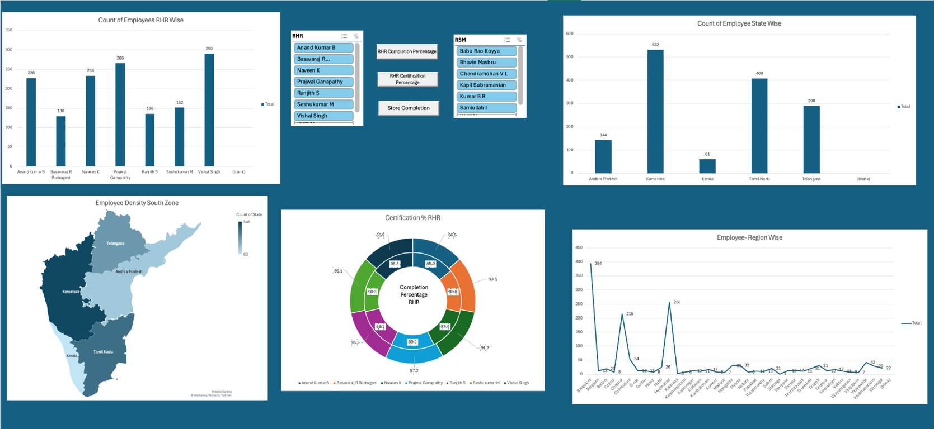

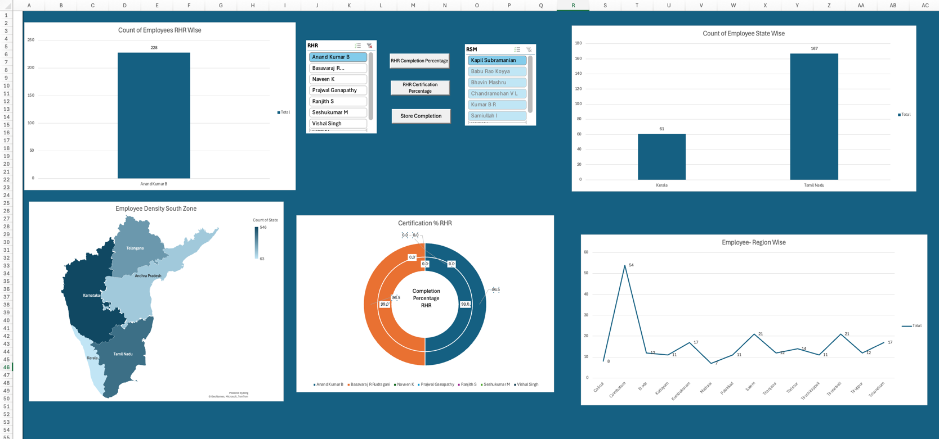

1. Extract HR Data from SAP through OData Services

• The Pantaloons IT/ABAP team develops both custom and standard OData services within SAP to unveil essential HR information, including employee profiles, training programs, completion statuses, scores, and specific regional fields.

• These services function as secure endpoints that permit access to data in an organized format (JSON/XML) over the web.

2. Set Up Authorization and Data Access

• Access to these OData services is governed by role-based authorizations in SAP, ensuring that only permitted users (e.g., Zonal HRs, Admins) can obtain pertinent data.

• Authentication methods generally employed include OAuth 2.0, SAML-based single sign-on, or SAP logon tokens, depending on Pantaloons’ IT infrastructure.

3. Link Excel to SAP via Power Query

• Within Excel, the HR Analytics team utilizes Power Query (Get &amp; Transform Data) to connect with the SAP OData endpoint using the necessary authentication method.

• Excel retrieves the data in real-time (or upon refresh) by executing HTTPS GET requests directed at the endpoint.

4. Process and Organize Data in Excel

• With the ETL features of Power Query, the obtained data is refined and organized:

o Unwanted columns are discarded.

o Status fields are classified (e.g., "Completed," "Pending").

o Regional and store-level mappings are uniformed.

o Dates are adjusted for consistent formatting.

5. Integrate into Data Model and Create Dashboard

• The refined data is incorporated into the Excel Data Model (Power Pivot), enabling the creation of advanced measures and KPIs via DAX formulas.

• Charts, slicers, PivotTables, and conditional formatting are employed to develop a live HR dashboard representing module completion by:

o Region

o Employee

o Type of module

o Certification status

6. Automate Refresh with Macros

• VBA Macros facilitate the automation of data refresh. A macro button can be included in the dashboard that:

o Executes ThisWorkbook. RefreshAll

o Initiates re-fetching of data from SAP

o Automatically updates all visuals and metrics in Excel

• Optional error handling or refresh logs may be incorporated to alert users to any failed connections or outdated credentials.

**HOW ADDITIONAL DROP/MODULE COMPLETION CAN BE ADDED IN EXCEL**

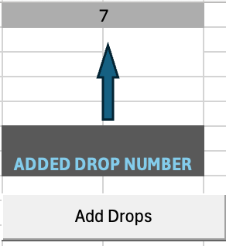

* In the Initial Sheet a Macro is labelled as Add Drops so as to Update the Base Sheet and Added all updates of Employees to the Pivot Tables so that the Graphs and Slicer in the Main Dashboard Can be Updated as per Entries made.

**CALCULATIONS DONE USING MACROS FOR RHR AND RSM**

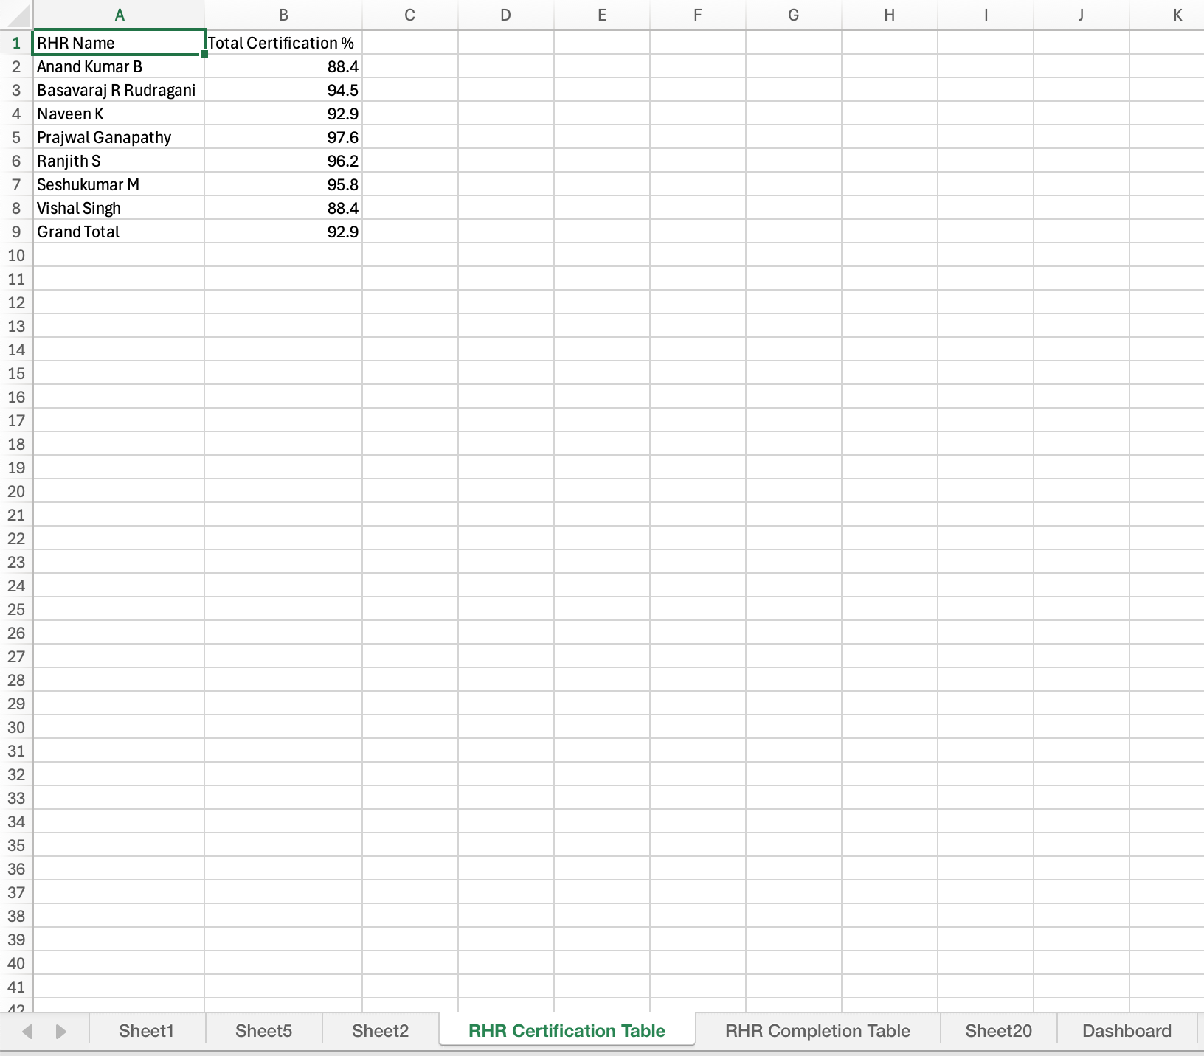

* Using the Set Macros in the Dashboard New Tab Calculations are done in relation to No of Employees Completed + Certified / Total No of Employees * 100 in order to get Total Certification Percentage in relation to each RHR.
* Using the Set Macros in the Dashboard Window RHR Completion is also calculated as a percentage of Total Completion/Total No of Employees.

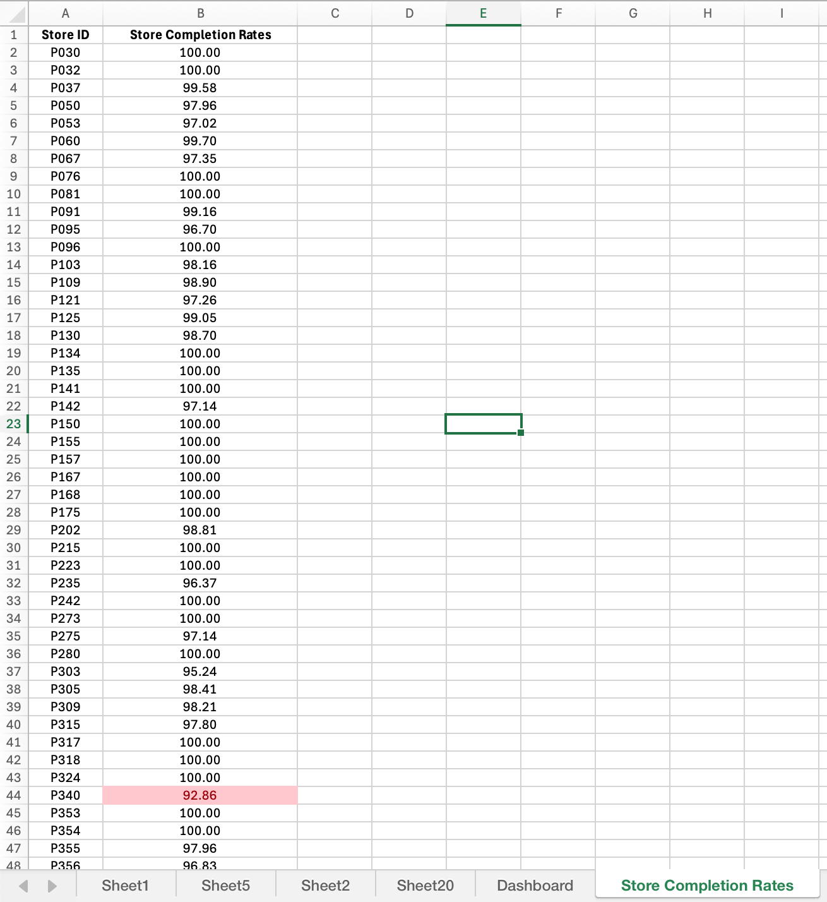

* Conditional Formatting Applied to the Macro that Calculates Store Completion Rate to highlight when Stores go below 95% Completion and Appropriately and timely informing the Store Manager along with the responsible RHR and RSM.

**CHAPTER 5**

# FINDINGS

1. Enhanced Data Integrity &amp; Validation

• Rule-Based Ingress Validation

o Implements stringent validation protocols at both client and server levels, utilizing regular expressions in conjunction with checksum algorithms to confirm the formats of key fields (like employee IDs and national identifiers) during data entry.

o Halts the registration of incorrect or malformed data instantly by rejecting entries that do not meet compliance standards in real-time, thus eliminating costs associated with downstream corrections while maintaining robust referential integrity among interconnected modules.

• Proactive Error Prevention

o Establishes preventative measures to detect and block field-level mistakes, such as incomplete or invalid date inputs (for instance, submitting 'D' instead of a proper date).

o Employs dynamic indicators for field status, disabling submission or visually and programmatically flagging incorrect inputs prior to reaching the backend database.

• Automated Data Formatting

o Leverages sophisticated input masks, contextual auto-completion, date pickers, and live field validators to automatically standardize inputs for dates, numerical codes, and identifiers.

o Minimizes manual entry errors and formatting discrepancies, historically accountable for up to 80% of typographical errors, thereby augmenting data cleanliness for subsequent analytics and cross-system integrations.

2. Attained Real-Time Cross-Module Consistency

• Event-Driven Architecture

o Utilizes both synchronous and asynchronous data integration through advanced messaging middleware, such as Kafka or RabbitMQ, facilitating real-time notifications and dissemination of changes across all HR ERP modules.

o Guarantees that HR data events provoke immediate updates, maintaining data accuracy and transactional consistency irrespective of the complexity or the volume of simultaneous operations.

• Live HCM Integration (SAP PA20)

o Direct real-time connection between the ERP core and the HCM (Human Capital Management) module ensures that updates in employee master data (like profile modifications and organizational shifts) are instantly mirrored in all pertinent business functions (payroll, compliance, access permissions).

• Dynamic Training Record Updates (SAP LSO_TAKEN)

o Smooth integration with the Training module allows for instant updates and synchronization of learning achievements, certifications, and skill matrices as employees finalize their training.

o Facilitates ongoing learning pathways, real-time compliance tracking, and current reporting on skill availability throughout the organization.

3. Strong &amp; Resilient Integration Strategy

• Primary API-First Approach

o Adopts OData (Open Data Protocol) APIs as the principal method for communication with both external and internal systems, encouraging secure, dependable, and high-volume data exchanges.

o Separates data synchronization logic from outdated screen-based automation, streamlining system maintenance while improving scalability.

• Automatic Failover Mechanism

o Incorporates intelligent routing that reverts to OData API-driven interactions when GUI scripting—often susceptible to disruptions due to front-end alterations or system updates—fails, guaranteeing seamless data flows.

o Upholds high system availability and business continuity by eliminating the need for manual interventions, even amidst unexpected UI or procedural anomalies.

4. Complete &amp; Compliant Auditability &amp; Security

• ISO 27001-Compliant Logging

o Each user action, data access, system alteration, and API transaction is carefully logged in accordance with ISO 27001 security regulations.

o Each log entry captures detailed context, including unique user IDs, exact timestamps, IP addresses, and before/after conditions for significant transactions—enabling swift forensic analysis and regulatory compliance.

• Immutable Audit Trails

o Audit logs are designed to be append-only and secured with cryptographic methods to guarantee that historical information is protected against tampering. This upholds the utmost standards for evidence integrity in external audits and incident investigations.

• Centralized Log Management

o Employs centralized Security Information and Event Management (SIEM) systems to aggregate, correlate, and analyze audit data in real-time comprehensively.

o Fosters advanced monitoring for threats, automates alerts, and simplifies compliance reporting, thus enhancing IT governance and security stance.

5. Accelerated Reporting &amp; Advanced Analytics

• Real-Time Reporting Cycles

o Transitioning from traditional batch reporting to event-based data streaming, this approach delivers real-time analytics within management dashboards and operational reports.

o Equips line managers and executives to make prompt decisions predicated on up-to-date information, enhancing adaptability and responsiveness to market or workforce changes.

• Faster Complex Query Processing

o Utilizes in-memory analytics, optimized database indexing, and pre-aggregated structures such as data cubes and views to significantly improve response times for complex, multi-dimensional reports across divisions.

• Reduced Data Discrepancies

o Consolidates all HR information into a single, cohesive repository, with integrated validation at every ingestion point to minimize mismatches and duplicates that arise from isolated systems.

6. Enhanced Workforce Management &amp; Optimization

• Elimination of Unofficial Tracking

o Combines attendance, performance, skill, and training records into one definitive platform, eliminating the necessity for spreadsheets or external tracking that may create inaccuracies.

o All workforce metrics are automatically recorded and verified, promoting consistent and audited documentation.

• Early Skill Gap Identification

o Employing real-time analytics to refresh an organization-wide skills inventory, utilizing machine learning to identify competency shortfalls and propose targeted upskilling opportunities.

o Automated processes initiate training or succession planning actions as soon as gaps are identified.

• Visual Compliance Monitoring

o Offers interactive dashboards that allow detailed exploration of compliance risk factors, alongside real-time tracking of mandatory certifications and automated alerts for any expiring accreditations or non-compliance situations.

o Facilitates focused and efficient audits while proactively addressing any identified gaps.

7. Optimized System Architecture &amp; Support

• Hybrid System Architecture

o Utilizes a combination of cloud-based and on-premises resources, optimizing for scalability (to manage variable workloads and high concurrency) alongside data residency and security needs.

o Delivers cost benefits and robust failover strategies to safeguard business continuity, even during disaster recovery scenarios.

• Reduced Technical Support

o Introduces self-service HR portals and AI-enhanced chatbots, empowering employees to handle common inquiries and requests on their own.

o Employs proactive system monitoring and automated incident resolution technologies, reducing reliance on manual IT support or prolonged downtime.

8. Data-Driven Training &amp; Future Workforce Planning

• Accelerated Employee Readiness

o Integrates a comprehensive Learning Management System (LMS) that customizes learning pathways and tracks real-time progress aligned with individual competency frameworks.

o Includes continuous feedback mechanisms and progress analytics to increase engagement and prepare for new business endeavors.

• Optimized Training Programs

o Uses real-time data on workforce performance and training to perform dynamic needs assessments and modify curricula to meet changing business demands.

o Measures, tracks, and reports on training effectiveness through key performance indicators that align with organizational goals.

• Predictive Competency Capability

o Employs predictive analytics to anticipate future skill requirements and pinpoint emerging deficiencies, promoting data-driven scenario planning for hiring, succession, and skill enhancement.

o Delivers timely alerts for expected talent deficits, allowing for proactive measures and ongoing organizational competitiveness.

# Chapter 6 CONCLUSION &

**RECOMMENDATIONS**

## CONCLUSION

Pantaloons is presently dealing with a range of intricate operational hurdles that stem from outdated manual procedures, disjointed data management, and reactive workforce approaches. The dependence on manual systems to monitor training progress has led to inconsistent data quality, hindering HR's capacity to acquire precise and timely information regarding employee skill enhancement.

This problem is further intensified by a lack of visibility into compliance adherence, which presents risks of regulatory failures that could ultimately disrupt store operations and tarnish brand reputation. Additionally, workforce planning largely remains reactive, exhibiting minimal predictive capabilities to anticipate skill deficits or talent shortages, thus exerting excessive pressure on HR teams striving to meet sudden needs and affecting performance stability across Pantaloons' retail network.

The introduction of a cutting-edge, automated HR analytics dashboard symbolizes a significant turning point, set to revolutionize the framework by embedding data-driven decision-making at the heart of Pantaloons’ workforce management structure. This advanced platform harnesses continuous, real-time data streams that instantly collect and unify diverse HR data sources, providing unparalleled clarity into employee training completion, compliance status, and developing competency profiles. With such real-time operational insights, HR leadership can transition from conventional reactive approaches to a proactive, forward-thinking model that aligns workforce investments with corporate objectives. Predictive analytics underpin this transformation by forecasting workforce trends and skill requirements ahead of time, facilitating strategic talent acquisition, focused upskilling efforts, and succession planning strategies that help avert costly skill shortages before they affect business operations.

Moreover, the dashboard's seamless integration across essential enterprise modules—including personnel administration systems like SAP PA20 and learning management systems such as SAP LSO_TAKEN—ensures comprehensive data consistency, transactional integrity, and eliminates redundancy and inaccuracies resulting from siloed or manual data entry methods. This architectural sophistication is further enhanced by the inclusion of intelligent failover mechanisms and adherence to open standards like OData APIs, ensuring strong, scalable, and secure data exchanges even in the face of system disruptions.

The platform's AI-powered decision support features enhance human decision-making by providing contextually pertinent recommendations for customized employee development plans and compliance risk mitigation strategies, thus improving workforce responsiveness and agility. Mobile-enabled learning access democratizes training, equipping frontline employees with educational resources available anytime and anywhere, which speeds up their preparation for new roles, technologies, or business efforts, while encouraging ongoing professional development. In addition, the establishment of automated, closed-loop compliance workflows, reinforced by ISO 27001-aligned audit trails, guarantees real-time governance, auditability, and prompt resolution of compliance issues, significantly lowering administrative burdens and allowing Pantaloons to uphold stringent control over regulatory requirements.

This foundation is supported by a hybrid infrastructure model that thoughtfully balances cloud scalability with on-premises security and resilience, enabling Pantaloons to optimize expenses and maintain continuous system availability across widely scattered retail locations. Together, these technological innovations empower Pantaloons to move beyond merely addressing superficial operational inefficiencies and to adopt a holistic talent management ecosystem capable of safeguarding workforce development in the rapidly changing retail landscape.

The forthcoming stage of innovation, which emphasizes greater AI incorporation, improved user experience, and broader automation capabilities, will significantly influence Pantaloons' direction—deciding if it will merely adapt and evolve within industry standards or boldly position itself as a trailblazer that revolutionizes HR digital transformation, operational excellence, and workforce optimization benchmarks across the retail sector.

## RECOMMENDATIONS

## 1. Expand Automation in Training and Compliance

* Implement fully automated, closed-loop compliance workflows to ensure instant identification and escalation of regulatory deviations.
* Integrate advanced Learning Management System (LMS) features—such as automated course assignments, progress alerts, and compliance tracking—to minimize manual intervention for training needs.
* Ensure training dashboards and compliance metrics are accessible via mobile platforms for better reach to store-level employees.

## 2. Advance Predictive Analytics and Workforce Planning

* Deploy AI-driven predictive models to forecast workforce requirements, anticipate skill gaps, and recommend targeted upskilling initiatives.
* Use scenario planning tools to simulate the impact of business changes, supporting proactive talent acquisition and succession management.
* Regularly update analytics algorithms with real operational data to increase the accuracy of future workforce predictions.

## 3. Strengthen System Integration and Data Consistency

* Prioritize seamless, real-time integration between personnel administration, learning, and compliance systems to eliminate data silos and ensure immediate reflections of employee changes.
* Standardize on open API frameworks (like OData) for all integrations, enabling scalability, maintainability, and resilience against front-end changes or system disruptions.
* Conduct periodic audits of cross-module data consistency and automate correction routines for discrepancies.

## 4. Enhance Security and Audit Capabilities

* Continue adherence to ISO 27001 standards; regularly review and enhance audit log granularity, retention policies, and centralization via Security Information and Event Management (SIEM) solutions.
* Train HR and IT teams to leverage audit data for real-time compliance risk analysis, not just after-the-fact investigations.
* Incorporate automated anomaly detection tools to flag unusual system accesses or data modifications.

## 5. Optimize Employee Experience and Self-Service

* Expand and refine self-service portals and AI-powered chatbots for routine HR requests, training access, and compliance queries.
* Invest in mobile-first user experience design to ensure that frontline staff in stores have intuitive, anytime access to HR tools and learning resources.
* Collect regular user feedback to continuously iterate on interface design and feature prioritization.

## 6. Extend Change Management and Skills Adoption

* Roll out targeted change management programs—using the dashboard’s analytics—to identify, coach, and support users lagging in technology adoption or compliance.
* Facilitate workshops and knowledge-sharing forums to promote data literacy and self-sufficiency in leveraging new HR tools.
* Link upskilling and digital adoption incentives with internal recognition programs to encourage broad participation.

## 7. Prepare for Future Enhancements

* Design the architecture with scalability in mind: anticipate future integration of advanced AI models, new compliance regulations, and rapid business expansion or pivots.
* Regularly benchmark system performance and feature set against retail industry leaders to maintain or surpass best practices.
* Stay engaged in technology forums and vendor roadmaps to remain at the forefront of HR digital transformation trends.

**CHAPTER 7**

# LEARNINGS

1. Broaden Automation in Training and Compliance

• Establish fully automated, closed-loop compliance systems that facilitate immediate recognition and escalation of regulatory issues.

• Incorporate sophisticated Learning Management System (LMS) functionalities—such as automatic course assignments, progress notifications, and compliance monitoring—to reduce manual oversight for training requirements.

• Make training dashboards and compliance indicators accessible through mobile devices to enhance accessibility for store-level workers.

2. Enhance Predictive Analytics and Workforce Planning

• Utilize AI-driven predictive frameworks to estimate workforce needs, identify skill shortages, and propose specific upskilling programs.

• Employ scenario analysis tools to model the repercussions of business shifts, aiding in proactive talent recruitment and succession planning.

• Frequently refresh analytics algorithms with actual operational insights to boost the reliability of future workforce forecasts.

3. Improve System Integration and Data Integrity

• Focus on achieving seamless, real-time integration among personnel management, learning, and compliance platforms to eliminate data silos and guarantee prompt updates of employee information.

• Adopt standardized open API protocols (such as OData) for all integrations to facilitate scalability, maintenance, and resilience contra front-end modifications or system failures.

• Perform regular assessments of inter-module data integrity and automate corrective actions for inconsistencies.

4. Augment Security and Audit Functionality

• Continue to adhere to ISO 27001 standards; consistently evaluate and enhance the detail of audit logs, retention policies, and centralization using Security Information and Event Management (SIEM) solutions.

• Train HR and IT personnel to utilize audit information for real-time compliance risk evaluation, rather than solely relying on post-event investigations.

• Implement automated anomaly detection mechanisms to identify irregular system access or changes to data.

5. Refine Employee Experience and Self-Service Options

• Develop and enhance self-service platforms and AI-driven chatbots for handling routine HR inquiries, training access, and compliance concerns.

• Invest in mobile-first design for user experience to guarantee that store employees can easily access HR tools and learning materials anytime.

• Gather consistent user feedback to iteratively improve interface design and prioritize features.

6. Enhance Change Management and Skill Adoption

• Implement focused change management initiatives—utilizing dashboard analytics—to pinpoint, mentor, and assist users who are struggling with technology adoption or compliance.

• Organize workshops and knowledge-sharing sessions to foster data literacy and independence in utilizing new HR technologies.

• Connect upskilling and digital adoption incentives with internal recognition systems to promote widespread engagement.

7. Prepare for Future Developments

• Architect the system with growth in view: plan for the future integration of advanced AI technologies, new compliance guidelines, and swift business transitions or shifts.

• Continually measure system performance and feature sets against leading retailers to ensure alignment with or superiority over best practices.

• Remain active in technology discussions and vendor plans to stay at the leading edge of trends in HR digital transformation.

# REFERENCES

* <https://www.abfrl.com/>
* <https://www.screener.in/company/ABFRL/consolidated/>
* <https://en.wikipedia.org/wiki/Aditya_Birla_Fashion_and_Retail>
* <https://www.pantaloons.com/>
* <https://www.moneycontrol.com/india/stockpricequote/retail/adityabirlafashionretail/PFR>

**APPENDIX**

]





